Docker-compose

Q1

- Install docker compose package after installing docker and starting it using the command:

apt-get install docker-compose

- Create a directory named DockerComposeFile and move into it using mkdir and cd commands.

- Create the four files namely app.py,requirements.txt,docker-compose.yaml,Dockerfile and add the following contents in those files

- Code in docker-compose.yaml file is as follows:

version: '2'
services:
web:
build: .
ports:
- "5000:5000"
redis:
image: "redis:alpine"

The web service:
Uses an image that's built from the Dockerfile in the current directory.Forwards the exposed port 5000 on the container to port 5000 on the host machine. We use the default port for the Flask web server, 5000.

- Dockerfile has the following code in it

FROM python:3.7-alpine
ADD . /code
WORKDIR /code
RUN pip install -r requirements.txt
CMD ["python", "app.py"]

This tells Docker to do the followings:

1.build an image starting with the Python 3.7 image.
2. add the current directory . into the path /code in the image.
3. set the working directory to /code. Note that the WORKDIR instruction sets the working directory for any RUN, CMD, ENTRYPOINT,
4. COPY and ADD instructions that follow it in the Dockerfile.
5.install the Python dependencies.
6.set the default command for the container to python app.py.

- app.py file

import time
import redis
from flask import Flask

app = Flask(__name__)
cache = redis.Redis(host='redis', port=6379)

def get_hit_count():
retries = 5
while True:
try:
return cache.incr('hits')
except redis.exceptions.ConnectionError as exc:
if retries == 0:
raise exc
retries -= 1
time.sleep(0.5)

@app.route('/')
def hello():
count = get_hit_count()
return 'Hello World! I have been seen {} times.\n'.format(count)

if __name__ == "__main__":
app.run(host="0.0.0.0", debug=True)

- Create a requirements.txt file and add flask,redis.

- After creating the four files, execute the docker compose using the command

docker-compose up

Compose pulls a Redis image, builds an image for our code, and starts the services (web and redis) we defined.

- Security group rules of the instance should allow port 5000.

- After successful execution of the docker compose command go to the url

http://<publicip>:5000
Then it shows a hello message and also shows the no. of times that url is hit.By reloading it the number increases.



After reloading the page:


The screenshot of docker-compose execution is as follows:

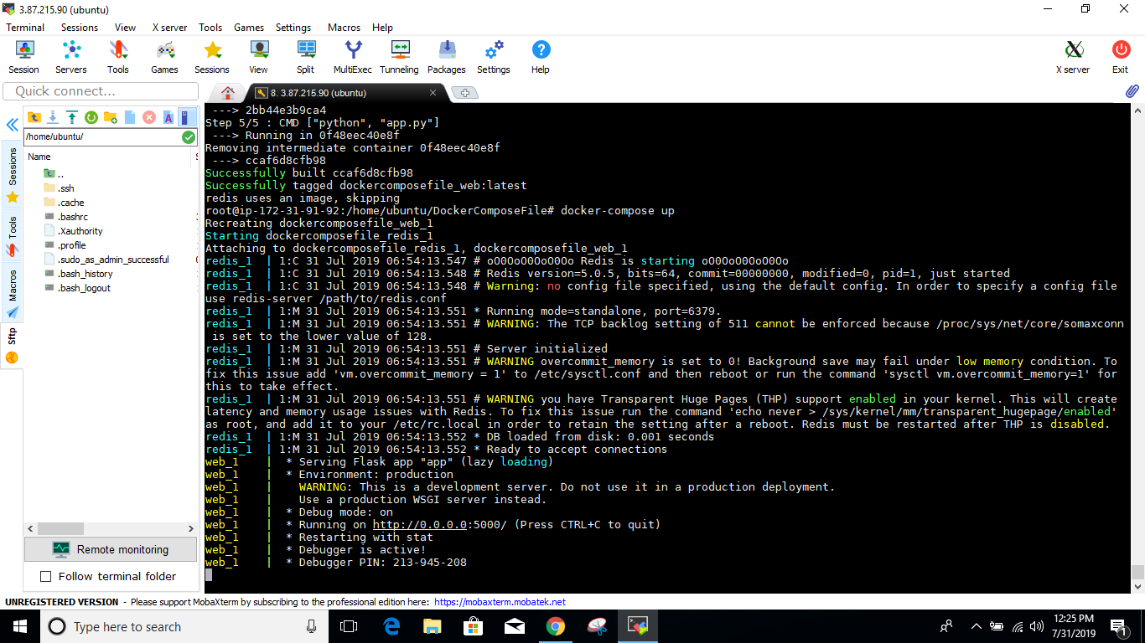

Q2:

Now, to create a volume,mount it and configure it, docker-compose.yaml file is modified as follows:

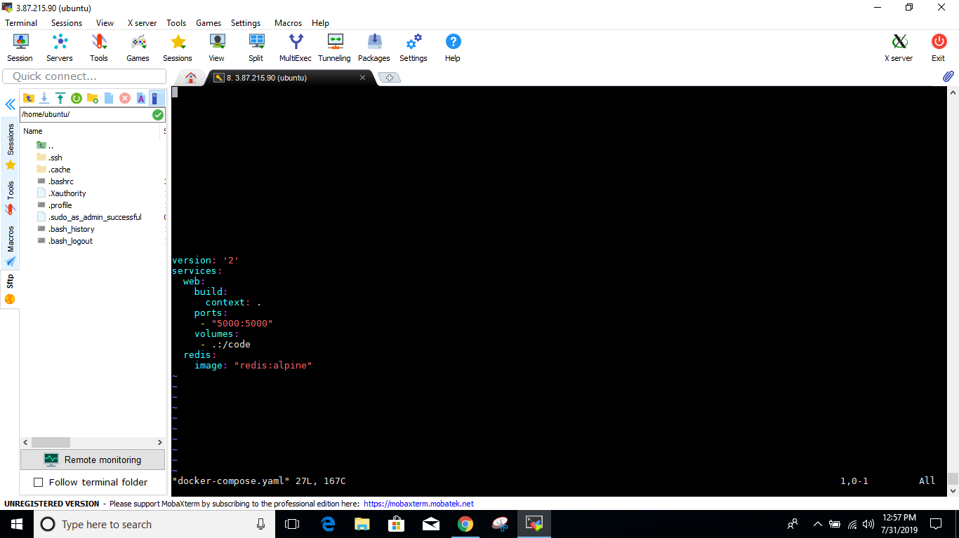

version: '2'
services:
web:
build:
context: .
ports:
- "5000:5000"
volumes:
- .:/code
redis:
image: "redis:alpine"

Here, a bind mount is aded for the web service. The new volumes key mounts the project directory (current directory, '.') on the host to /code inside the container, allowing us to modify the code on the fly, without having to rebuild the image.

Now, again use docker-compose up command to test the application
Go to the url and reload it to see if it works.

The count increased from 2 to 3 as shown below.



Now, if some changes are made to the python code, and the url is hit again, the changes will appear without using the compose command again.

